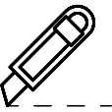SFA LIMITED TENT CARD TEMPLATE

Tent Card Die Cut Template

Size 105mmH x 140mmW

Remarks: In order to obtain the best quality, please use 150 gsm paper or above

Paper Size: A3 420mm x 297mm

Your text here

Sake & Wine Card design for Restaurant table. Find a template that makes your restaurant stand out…read more

**餐桌酒卡設計下載，讓您餐廰能脫穎而出的餐桌酒卡樣板...查看更多**

Company Name

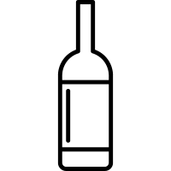

Your text here

Sake & Wine Card design for Restaurant table. Find a template that makes your restaurant stand out…read more

**餐桌酒卡設計下載，讓您餐廰能脫穎而出的餐桌酒卡樣板...查看更多**

Company Name



294mmW

140mmHW